Goge LLM

1. Particulars of Inventors
Inventors: the person listed below
Note: Highlighted cells are to be completed by the inventor.
Mr./Ms./Dr. | Name (Full) | Mobile No. | Email | Address
Mr. | Nishant Sharma Neupane | +977 974-7716789 | ourfreelancer567@gmail.com | Kathmandu,Nepal, 44600

2. Title of the invention
GOGE LLM: A Compact Self-Developed Encoder–Decoder Language Model with Layered Gated Self-Attention and Lightweight Deployment for Domain-Specific Applications

3. Abstract
Goge LLM is a compact language-model architecture developed from scratch by the inventor, with a model footprint of approximately 173 MB. Input text is tokenized and embedded, then processed by a 16-layer encoder with a gated self-attention block that selectively controls contextual information. The resulting context representation is passed to a 32-layer decoder organised into two blocks with gated self-attention, followed by linear projection and softmax to generate the output sequence. The compact core is designed for embedding into application software, including banking and healthcare workflows, with authorization, validation and safety controls handled at the application level.

4. Detail description of the invention

a. Problem the invention is solving
Large language-model systems are difficult to deploy in resource-constrained or specialised environments because of their model size, computational requirements and integration complexity. General-purpose models often need dedicated GPU servers or cloud access, which is costly and not always permitted for sensitive domains such as banking and healthcare. Application developers also have to build separate logic around a large external model to make it usable inside a domain workflow.
The invention addresses this with a compact, self-developed architecture (about 173 MB) that keeps a structured, deep encoder–decoder pipeline and adds gated self-attention for controlled contextual processing, so that the model can be embedded as a language-processing core inside application software.

b. General utility / application of the invention
- Text understanding, contextual representation and sequence generation or transformation.
- Lightweight language-processing components inside software applications.
- Banking applications: permitted customer queries, document/text processing and workflow assistance, with banking rules and authorization handled by the application.
- Healthcare applications: permitted information processing and user-facing language assistance, with clinical authorization, validation and safety controls handled by the application.
- Deployment, after appropriate optimisation/quantization, on constrained computing environments.

c. Advantages of the invention disclosing about the increased efficiency/efficacy
- Compact model footprint of approximately 173 MB as currently implemented.
- A deep 16-layer encoder and 32-layer decoder provide a structured, multi-stage language-processing pipeline.
- Gated self-attention selectively controls which contextual information is passed on during processing.
- Encoder–decoder separation provides a defined path from input representation to generated output.
- The model can be integrated into application-specific workflows without making the application itself part of the model architecture.

d. Best way of using the invention as well as possible variants
Best mode: a 16-layer encoder with one encoder-side gated self-attention block, and a 32-layer decoder arranged as two blocks with gated self-attention applied, followed by linear projection and softmax, with a total footprint of about 173 MB. The model is embedded as the language core of a banking or healthcare application, which supplies the authorized domain data/rules and the validation guardrails (Fig. 2).
Variants: changes in layer counts, attention placement, gating formulation, embedding dimensions, vocabulary/tokenization, decoder block organisation, numerical precision, quantization level or deployment hardware, while retaining the underlying encoder–decoder and gated-attention concept.

e. Working of invention along with drawing, schematics and flow diagrams with complete explanations
The model architecture is shown in Fig. 1 and the application embodiment in Fig. 2 (Section 13).
- Input text (or tokens) is received.
- The text is tokenized and converted into numerical embeddings.
- The embedded sequence is processed by the 16-layer encoder.
- The gated self-attention block works on contextual relationships and outputs a controlled contextual representation (context vector).
- The context representation is fed into the 32-layer decoder, split into two processing blocks, which applies gated self-attention while decoding.
- The decoder output passes through a linear projection and softmax to obtain token probabilities.
- Output tokens are generated autoregressively until the end-of-sequence token is reached.
In the application embodiment (Fig. 2), the user input or record is preprocessed and tokenized, encoded by Goge LLM, checked against authorized domain data/rules, passed through validation/guardrails, and returned as a response or workflow action.

5. Have you conducted Primary Patent Search? Yes / No (if yes, attach the patent search report)
No.

6. Brief background of the existing knowledge/product/process in the market
The technical field of this disclosure is transformer-based encoder–decoder language models, self-attention mechanisms, autoregressive decoding, and the compression and deployment of language models. Widely used language models are large, general-purpose systems that need substantial memory and compute and are usually accessed through cloud services. Smaller models are commonly obtained by compressing large ones rather than by designing a compact architecture from the start.
The disclosure is directed to the specific implementation and arrangement made by the inventors, not to the general concepts of tokenization, attention, encoder–decoder processing or softmax taken individually.

7. Known ways others have tried to solve the same or similar problems, their disadvantages, and prior art
Note: entries below are indicative and should be verified and supplemented by the patent search (Q5).
S. No. | Existing state of art | Drawbacks in existing state of art | Overcome (how your invention is overcoming the drawback)
1 | Large / general-purpose language models | Higher resource and deployment requirements; often need cloud or dedicated GPU servers | Compact self-developed model with a substantially smaller footprint (~173 MB)
2 | Standard attention-based architectures | Attention weighs contextual relevance without the disclosed gating arrangement | Gated self-attention is incorporated into both encoder and decoder processing
3 | Application-specific AI systems | Often need separate application logic built around a large external model | Model is designed as a compact language core that embeds into banking/healthcare workflows, with domain controls kept outside the model

8. List the technical features and elements of the invention along with the description from start to end
Technical features / elements (reference to Fig. 1):
- E1. Input module receiving text or tokens.
- E2. Tokenizer and embedding layer converting input into embedding representations.
- E3. 16-layer encoder stack.
- E4. Encoder-side gated self-attention block.
- E5. Context vector / encoded representation.
- E6. 32-layer decoder divided into two blocks.
- E7. Gated self-attention mechanism applied in the decoder.
- E8. Linear projection and softmax layer predicting output tokens.
- E9. Autoregressive generation until an end-of-sequence token is detected.
- E10. Compact implementation/deployment footprint of approximately 173 MB.
- E11. Application interface (Fig. 2) through which banking/healthcare software supplies authorized domain data/rules and validation guardrails, kept external to the model.
Description from start to end: (1) The application receives user input or a record. (2) The input is preprocessed, tokenized and embedded. (3) The 16-layer encoder with gated self-attention produces a controlled context representation. (4) The 32-layer, two-block decoder with gated self-attention generates output token by token through linear projection and softmax. (5) The application checks the output against authorized domain data/rules, applies validation/guardrails and returns the response or workflow action.

9. List out the features of your invention which are believed to be new (novel)
- N1. The specific combination of a compact (~173 MB) language-model implementation with the disclosed encoder–decoder depth configuration.
- N2. The 16-layer encoder and 32-layer, two-block decoder organisation.
- N3. The placement and use of gated self-attention in both the encoder and decoder processing path.
- N4. An end-to-end compact architecture tailored as an embeddable core for domain-specific application workflows, with authorization, validation and safety controls kept external to the model.

10. Has the invention been built or tested or implemented? (all testing details)
Yes – Goge LLM has been developed by the inventor as a self-constructed model requiring approximately 173 MB of storage.

11. Have you sold, offered for sale, publicly used or published anything related to this invention?
The patent application (at least a provisional specification) must be filed before any publication, presentation or public code release of the model.

12. How your invention is a technical advance (relevant facts and testing data)
The technical advance to be demonstrated is the combination of a compact model footprint with the disclosed layered encoder–decoder and gated self-attention structure, together with practical embedding into application pipelines.
- Size effect: approximately 173 MB footprint (as reported by the inventors).
Note: no accuracy or speed claims are made until verified test results are attached.

13. Drawings / Flowchart / Table
- Fig. 1: Main model architecture of Goge LLM (left)
- Fig. 2: Application embodiment in a banking / healthcare setting (right)
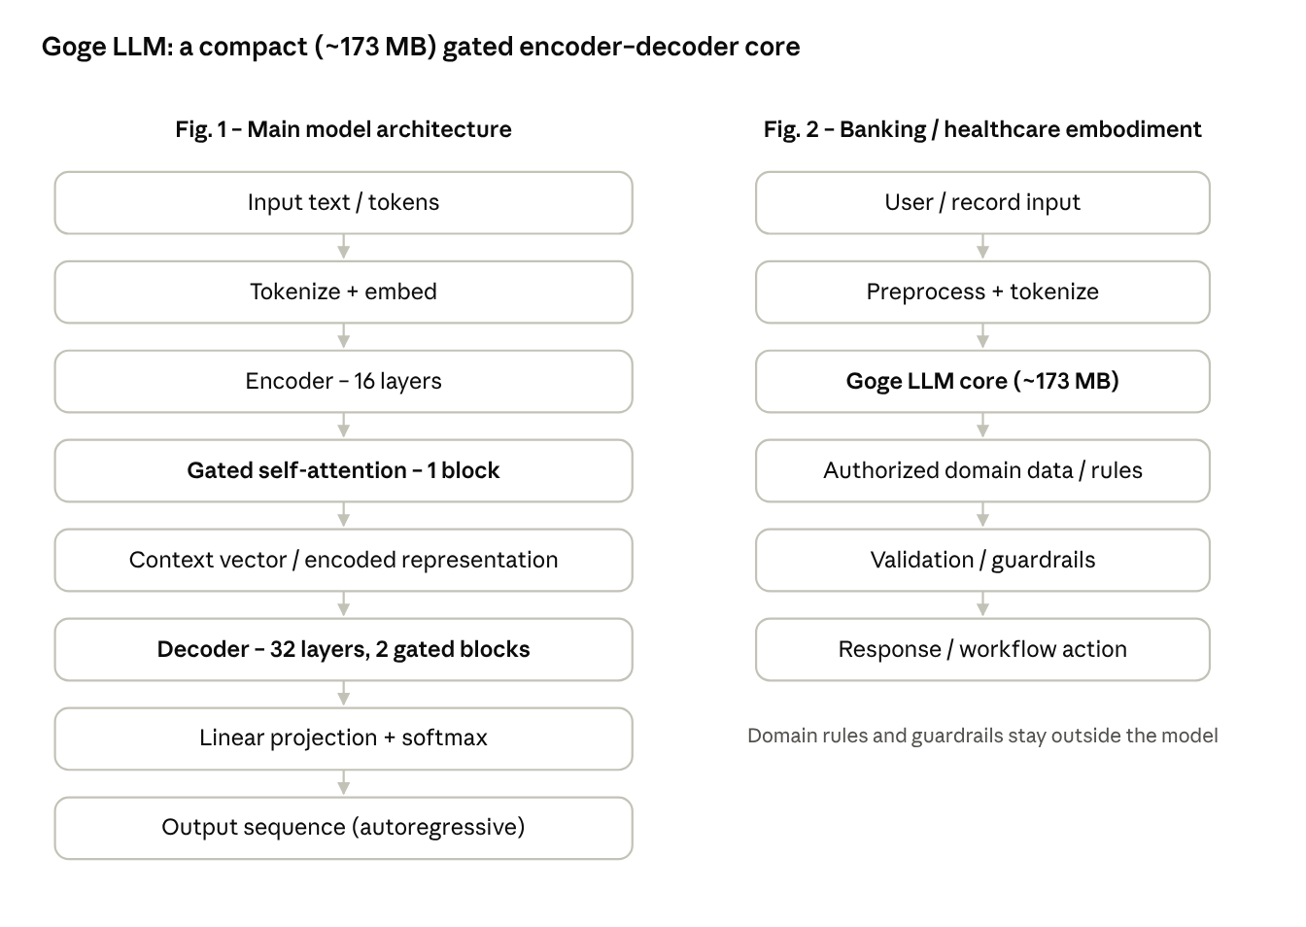
Fig. 1 model architecture · Fig. 2 banking/healthcare embodiment
The left flow is the model itself; the right flow shows the model embedded in an application, where domain rules and guardrails are applied outside the model. A formal patent drawing will be prepared from this flowchart.

Table 1: Architecture configuration of Goge LLM
S. No. | Component | Configuration | Purpose
1 | Tokenizer + embedding | Token embeddings | Converts text into numerical representations
2 | Encoder | 16 layers | Builds contextual representation of the input
3 | Encoder gated self-attention | 1 block | Selectively controls contextual information
4 | Decoder | 32 layers in 2 blocks, gated self-attention | Generates the output sequence
5 | Output layer | Linear projection + softmax | Predicts output token probabilities
6 | Model footprint | ~173 MB | Lightweight deployment

Signature of Inventors (Name)
Mr, | Name (Full) | Address | Signature
Mr. | Nishant Sharma Neupane | Kathmandu,Nepal,44600 | 

